HOW TO TRANSFER A UNIT TO A LENDER
Log into your Ituran Controlit account at www.ituranusa.com, enter your username and password
Click on the globe to open the menu, click on the Settings menu and select Lender Program
Click on Submit New Request option
Select the unit/vehicle from the drop down, select your program
Enter comments, name and emails, then click the Submit button
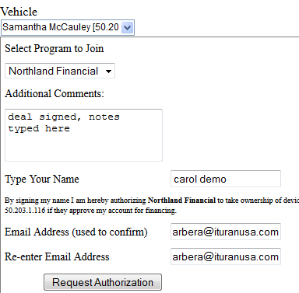
Once Lender approves the transfer, the unit will be moved out of your account and into Lender account
For now, it remains in your list as status “pending”
