HOW TO ACCEPT A UNIT INTO A LENDING COMPANY
Log into your Ituran Controlit account at www.ituranusa.com, Enter your username and password
Click on the Settings menu and select Lender Program
You will see a list of pending requests
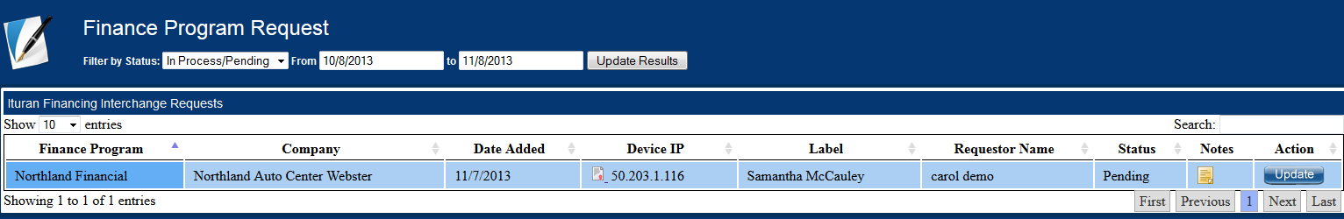
Click the Update button at the end of the record
It will open the screen below. Click on the dropdown of the Approval Status and select Approved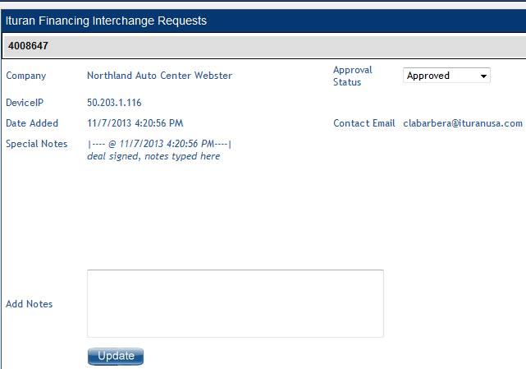
Type any notes you want to include and click Update. Now the status will change to Approved. Emails sent to confirm.
